Assignment - 1 (Day 3)

Name : GOKUL J B

Email id : jbgokul2000@gmail.com

Question

1. Create a blank file named "myfile"

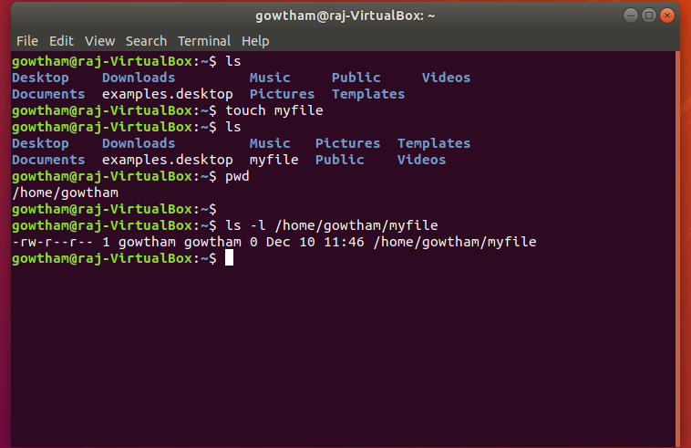

1. Open "myfile" in vi editor

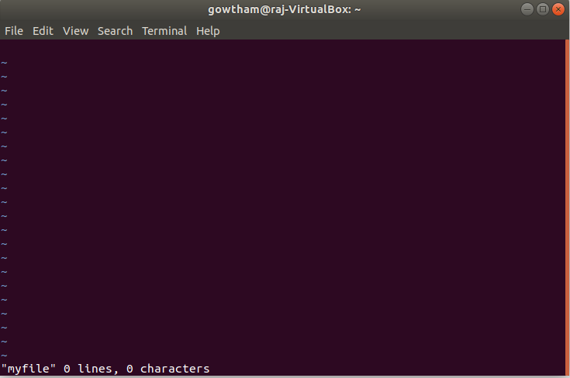

1. Write your name, address, email id, phone number different lines

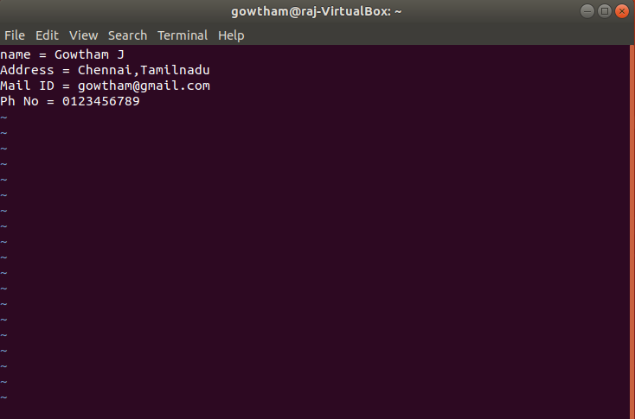

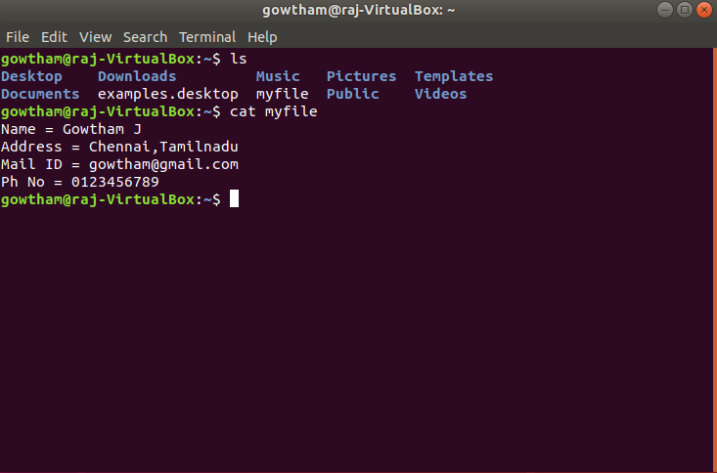

1. Build one single expression to see the line with your name and Phone Number in myfile

